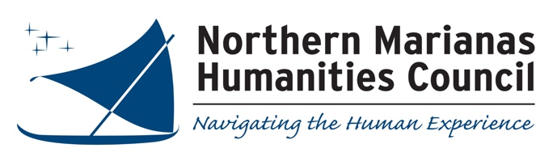
NOMINATION FORM
2020 Governor’s Humanities Awards
Name of Nominee: _______________________________________________________________

Nominee Mailing Address: _________________________________________________________

Work/Home Telephone: ___________________________email address: _________________________________

Nomination Category (please specify one):

________ Research and Publication in the Humanities

________ Outstanding Humanities Teacher _____ Classroom or _____ non-classroom setting

________ Preservation of Traditional Cultural Practices

________ Preservation of CNMI History

________ Lifetime Achievement in the Humanities

Provide a concise description of the nominee’s contributions to the humanities in the category listed:

(use continuation sheet if needed. Also be sure to attach supporting documentation, as appropriate).

Nomination submitted by: __________________________; Email:____________________________; Phone:_________________
2020 Governor’s Humanities Awards FAQs

What is the Governor’s Humanities Awards?
This is an annual program sponsored by the Northern Marianas Humanities Council in conjunction with the Office of the Governor that recognizes outstanding contributions to the humanities by individuals and organizations in our community.

What are the Humanities?
According to the Congressional definition, the humanities include the following fields: History; Philosophy; Languages; Linguistics; Literature; Archaeology; Jurisprudence; History and Philosophy of Science; Ethics; Comparative Religion; and social sciences employing historical or philosophical approaches to content such as cultural anthropology, sociology, political theory, international relations, and other subjects concerned with questions of human value.

What are the Awards Categories?
Research and Publication in the Humanities: Nominees under this category are recognized for original scholarly research in one or more of the humanities fields that resulted in a manuscript or in the publication of a book or article. Research and publication topics must relate directly to the Northern Mariana Islands or to the greater Pacific region.

Outstanding Humanities Teacher: Nominees under this category are recognized for significant contributions to humanities instruction. Nominees may be classroom teachers (K-college) or individuals involved in humanities instruction outside of the formal classroom setting.

Preservation of Traditional Cultural Practices: Nominees under this category are recognized for a significant contribution to preserving traditional cultural practices relating to such topics as language, subsistence, medicine, law, kinship, religion, construction and transportation, among others.

Preservation of CNMI History: Nominees under this category are recognized for significant contributions to preserving history relating to the Northern Mariana Islands. Such contributions may take the form of film and video projects, recording oral histories, and other projects that record and examine important aspects of local history.

Please insure that the nominee’s contribution in the above four categories was made within the past year.

Lifetime Achievement in the Humanities: This is the Council’s most prestigious award. Nominees in this category are recognized for significant contributions in one or more fields of humanities over the course of multiple decades typically three or more. This award may be presented posthumously.

What supporting documentation do I need to submit?
It is important that nominations contain a detailed and concise description of the nominee’s contribution to the humanities and when this contribution occurred. Supporting documentation might consist of the nominee’s resume or curriculum vita, articles and books, video clips, book reviews, newspaper and magazine clippings, and testimonials from the individuals knowledgeable about the nominee’s contributions. Please note that nominations that are poorly or incompletely described and documented will not be given serious consideration.

Where do I submit my nomination form?
Completed nomination forms must be received by the Northern Marianas Humanities Council no later than 4:00 pm on Friday, October 2, 2020. Nominations may be hand delivered to the Council’s office in the Spring’s Plaza Building in Gualo Rai, faxed to the Council at 235-4786, emailed to info@nmhcouncil.org or mailed to P.O. Box 506437, Saipan, MP 96950.

How will the Awardees be Selected?
Nominations received by the deadline will be selected by majority vote of the board of directors of the Northern Marianas Humanities Council. Awards will be presented during the 2020 Governor’s Humanities Awards Ceremony in October at a date and venue to be announced.

